

Science Department

Year 12 ATAR Chemistry

Test 2: Equilibrium

Name: _____________________________

Teacher: ____________________

**Instructions to Students:**

1. 50 minutes permitted

2. Attempt all questions

3. Write in the spaces provided

4. Show all working when required

5. All answers to be in blue or black pen, diagrams in pencil.

|  |  |  |  |  |  |  |
| --- | --- | --- | --- | --- | --- | --- |
| **Multiple Choice** |  | **Short Answer** |  | **TOTAL** |  | **Final Percentage** |
| /12 |  | /48 |  | /60 |  |  |

Questions 1 – 3 refer to the reaction and diagram below:

CH4 (g) + H2O (g)  3 H2 (g) + CO (g) ∆H = + 206 kJ

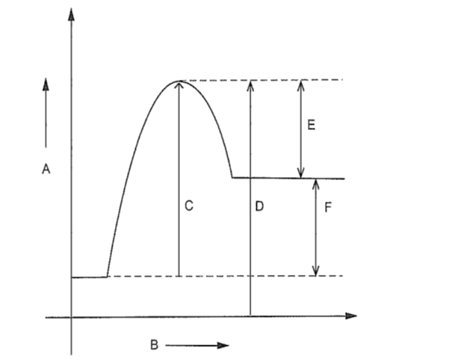

1. Which one of the following is true?
2. The forward reaction is endothermic.
3. The axis representing potential energy is B.
4. The enthalpy difference for the reaction is E.
5. The activation energy for the forward reaction is D minus C.
6. Which one of the following represents the activation energy for the reverse reaction?
7. C
8. D
9. E
10. D plus F
11. Which one of the following represents the heat of reaction for the forward reaction?
12. C minus D
13. E
14. C
15. F

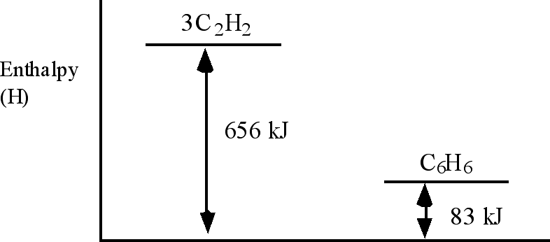

1. Use the information in the above diagram to calculate ∆H for the reaction

3C2H2(g) → C6H6(g)

1. + 739 kJ
2. + 573 kJ
3. - 573 kJ
4. - 656 kJ

The following information refers to the next two questions.

Examine the following potential energy diagram for a chemical reaction:

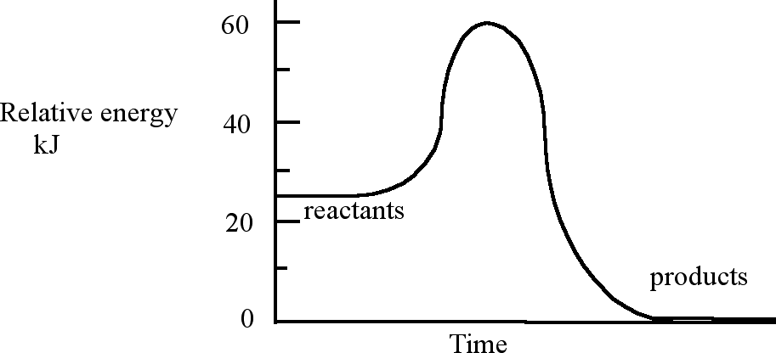

1. The enthalpy change ∆H and the activation energy Ea in kJ for the reaction are respectively
2. ∆H = –25 kJ and Ea = 35 kJ
3. ∆H = +25 kJ and Ea = 35 kJ
4. ∆H = +35 kJ and Ea = 60 kJ
5. ∆H = –60 kJ and Ea = 35 kJ
6. If a catalyst is added to the system (choose one answer):
7. both ΔH and Ea decrease
8. ∆H remains constant but Ea decreases
9. ∆H decreases and Ea remains constant
10. both ∆H and Ea remain constant.
11. The equilibrium constant, K, for the reaction, 2H2(g) + O2(g)  2H2O(g) ,

is equal to 2 x 1081  at 25oC. This value suggests that

a) this reaction favours the forward reaction slightly more than the reverse reaction.

b) this reaction favours the reverse reaction slightly more than the forward reaction.

c) this reaction virtually goes to completion with little reversal.

d) this reaction virtually does not proceed forward and largely favours the reactants.

1. The equilibrium expression, K, for the reaction below would be:

N2O4(g)  2NO2(g)

a) K = [N2O4]

2[NO2]

b) K = 2[NO2]

[N2O4]

c) K = [N2O4]

[NO2]2

d) K = [NO2]2

[N2O4]

1. What would happen to the value of K in the reaction described in question 8, if the pressure of the N2O4  is doubled?

a) K would not be affected.

b) K would be halved.

c) K would be doubled.

d) K would increase by a factor of 4.

1. What is the equilibrium constant expression for the dissolving of solid silver sulfate in water?
2. K = [Ag+]2 [SO42-]

[Ag2SO4] [H2O]

K = [Ag+] [SO42-]

[H2O]

(c) K = [Ag+]2 [SO42-]

[Ag2SO4]

(d) K = [Ag+]2 [SO42-]

**SECTION 1 (MULTIPLE CHOICE) CONTINUED ON NEXT PAGE**

**Questions 11 and 12 refer to the following diagram**

Aqueous solutions of copper (II) ions and ammonia form the equilibrium presented below:

[Cu(H2O)6]2+ (aq) + 4 NH3 (aq)  [Cu(NH3)4]2+ (aq) + 6 H2O (l)

Pale blue deep royal blue

The following graph shows the changes in concentration with time for [Cu(H2O)6]2+ and [Cu(NH3)4]2+ ions when solutions of copper (II) nitrate and ammonia are mixed.

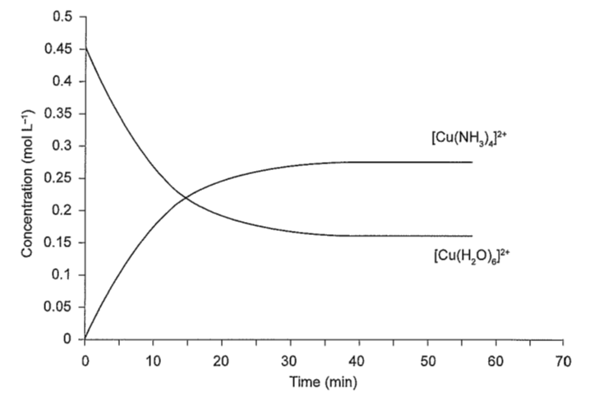

1. Which one of the following statements is true for this equilibrium system?
2. The system reaches equilibrium at approximately 35 minutes.
3. At equilibrium, the concentration of NH3 will always be four times

greater than the concentration of [Cu(NH3)4]2+

1. Adding ammonia to the system will decrease the equilibrium constant.
2. At equilibrium, the rate of the forward reaction is less than the rate of

the reverse reaction.

1. Which one of the following would be observed if a small quantity of concentrated nitric acid was added to the system after it had reached equilibrium?
2. The solution would be a deeper royal blue colour.
3. The solution would be a paler blue colour.
4. There would be no change in the colour of the system.
5. Copper(II) nitrate crystals would precipitate from solution.

**END OF SECTION 1**

**Section Two: Short answer (48 Marks)**

1. According to collision theory, what two criteria must be met before a molecular collision will result in a chemical reaction?

....................................................................................................................

................................................................................................................... (2)

1. State what is meant by the terms ‘rate of reaction’ and ‘activation energy’.

*Rate of reaction*...................................................................................

.............................................................................................................

*Activation energy*..................................................................................

.............................................................................................................

(3)

1. The diagram below shows the energy distribution curve for a sample of gas at a fixed temperature. Ea is the activation energy for the decomposition of this gas.



1. On this diagram sketch the distribution curve for the same sample of gas

at a higher temperature. (1)

1. What is the effect of an increase in temperature on the rate of a chemical

reaction? Explain your answer with reference to the energy distribution curve on the previous page.

*Effect*............................................................................................ (1)

*Explanation*..................................................................................

.....................................................................................................

..................................................................................................... (2)

1. What is the effect of the addition of a catalyst on the rate of a chemical

reaction? Explain your answer with reference to the energy distribution curve on the previous page.

*Effect*............................................................................................ (1)

*Explanation*..................................................................................

.....................................................................................................

..................................................................................................... (2)

1. The questions below refer to the equilibrium of Co(H2O)62+ and CoCl42- ions in solution.

Co(H2O)62+ (aq) + 4 Cl-  (aq) CoCl42- (aq) + 6 H2O (l) ∆H = positive

**Pink**  **blue**

1. Write the equilibrium constant expression for the following reaction. (1)

|  |
| --- |
|  |

1. What would be observed if a few drops of silver nitrate solution

(AgNO3 (aq)) were added? Explain this observation using

Le Chatelier’s principle. (3)

………….....................................................................................................

………….....................................................................................................

………….....................................................................................................

………….....................................................................................................

1. This question relates to the following reaction: (6)

N2 (g) + O2 (g)  2 NO (g)ΔH = + 180 kJ mol-1

Complete the table by predicting and **explaining** the effect on the position of equilibrium of the following imposed changes. **(simply stating Le Chateliers principle does not constitute an explanation)**

|  |  |  |
| --- | --- | --- |
| **Imposed change** | **Effect on equilibrium position**  (to right, to left, no change) | **Explanation** |
| Increased Temperature |  |  |
| Reduce the volume of the reaction vessel |  |  |
| Remove some of the NO (g) |  |  |

1. During the production of nitric acid, the following exothermic reaction occurs:

4 NH3 (g) + 5 O2 (g)  4 NO (g) + 6 H2O (g)

Chemical engineers would seek to try to increase both the rate and the yield for this process.

1. Give three actions, with brief explanations **using your knowledge of Collision theory**, that would maximise (increase) the **rate** of the forward reaction. (3)

|  |  |
| --- | --- |
| **Action** | **Explanation** |
|  |  |
|  |  |
|  |  |

1. Give two actions, with explanations **using your knowledge of Collision theory**, that would maximise the **yield** for the reaction. (4)

|  |  |
| --- | --- |
| **Action** | **Explanation** |
|  |  |
|  |  |

1. What would the chemical engineers have to do if an answer to (a) is an opposite action to an answer in (b)? (2)

…………………………………………………………………………………

…………………………………………………………………………………

…………………………………………………………………………………

1. In our blood, oxygen is transported by combining with haemoglobin in the blood according to the following reversible reaction to form

oxyhaemoglobin that travels around the body: (4)

HAEMOGLOBIN (aq) + O2 (g)  OXYHAEMOGLOBIN (aq)

The presence of carbon monoxide in the blood causes the following irreversible reaction.

HAEMOGLOBIN (aq) + CO(g)  CARBOXYHAEMOGLOBIN (aq)

The concentration of oxygen in a person’s blood is 0.01 mol L-1. The blood in the person’s body undergoes the following changes. Predict the effect of these changes on the oxygen concentration in the blood.

|  |  |  |
| --- | --- | --- |
| **Imposed change** | **Concentration of oxygen in blood.**  *(Circle correct answer)* | **Explanation** |
| Haemoglobin concentration in blood is increased.  *(high altitude training can achieve this)* | More than  0.01 mol L-1  0.01 mol L-1  Less than  0.01 mol L-1 |  |
| CO(g) levels in blood increases. | More than  0.01 mol L-1  0.01 mol L-1  Less than  0.01 mol L-1 |  |

1. The industrial process for converting ammonia into nitric acid is done in

three stages.

**Stage 1:** 4NH3(g) + 5O2(g)  4NO(g) + 6H2O(g) ∆H = –950 kJ mol–1

**Stage 2:** 2NO(g) + O2(g)  2NO2(g) ∆H = –114 kJ mol–1

**Stage 3:** 3NO2(g) + H2O(l)  2HNO3(aq) + NO(g) ∆H = –117 kJ mol–1

Consider the reaction in **Stage 1** above.

1. State how the temperature should be changed in order to **increase the yield** at equilibrium in this reaction. Explain using Le Chatelier’s principle. (3)

……………………………………………………………………………………

……………………………………………………………………………………

……………………………………………………………………………………

……………………………………………………………………………………

……………………………………………………………………………………

1. State how the pressure should be changed in order **to increase the yield** at equilibrium in this reaction. Explain using Le Chatelier’s principle. (3)

……………………………………………………………………………………

……………………………………………………………………………………

……………………………………………………………………………………

……………………………………………………………………………………

……………………………………………………………………………………

1. The Stage 1 reaction is carried out by passing ammonia and air over a platinum gauze at a temperature of 900°C and a pressure of

975 to 1225 kPa.

Using your knowledge of Collision Theory, what are the advantages of using this temperature and this pressure? (4)

……………………………………………………………………………………

……………………………………………………………………………………

……………………………………………………………………………………

……………………………………………………………………………………

……………………………………………………………………………………

1. Give a reason why the catalyst is used in the form of a gauze. (1)

……………………………………………………………………………………

……………………………………………………………………………………

……………………………………………………………………………………

1. Catalysts are expensive. They greatly increase the cost of a chemical process, yet are still economically viable. Explain the role of catalysts and why they are used despite the cost. (2)

……………………………………………………………………………………

……………………………………………………………………………………

……………………………………………………………………………………

**END OF TEST**